**Primarily Primes**

Even though 1 is not a prime number, all the other numbers needed to complete this magic square are prime.

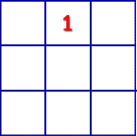

Can you complete the magic square by filling in prime numbers so that the sum of every row, column, and diagonal is 111?